

Individual Assignment Cover Sheet

**Leader : Ramiro Gunady ( 03082180067 )**

**Module : REKAYASA APLIKASI TERDISTRIBUSI**

**Class : 18TI3**

**Lecture / Tutor : Des Dulianto**

**Assigment Item / Title : PEMBUATAN APLIKASI TERDISTRBUSI**

**GAME THE EARTH**

**Date Due : April 17, 2021**

**Date Submitted : 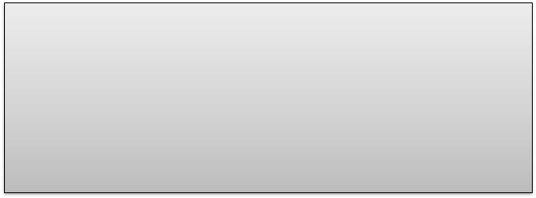April 29, 2021**

I declare that this assessment item is my own work, except where acknowledged, and has not been submitted for academic credit elsewhere, and acknowledge that the assessor of this item may, for the purpose of assessing this item

1. Reproduce this assessment item and provide a copy to another member of the University; and/or,

1. Communicate a copy of this assessment item to a plagiarism checking service (which may then retain a copy of the assessment item on its database for the purpose of future plagiarism checking).
2. I certify that we have read and understood the University Rules in respect of Student Academic Misconduct.

**Date: April 17, 2021**

 **DAFTAR ISI**

COVER …………………..……….......................................................................................... 1

DAFTAR ISI………................................................................................................................. 2

JUDUL

BAB I PENDAHULUAN

1.1 Latar Belakang ................................................................................................... 4

1.2 Rumusan Masalah ................................................................................................... 5

1.3 Tujuan Penelitian ................................................................................................... 5

1.4 Permasalahan ................................................................................................... 5

1.5 Batasan Masalah ………………………………………………………………... 5

1.6 Metodologi Pengembangan Software…………………………………………………… 6

BAB II Landasan Teori

2.1 User/System Requirement

2.1.1 User requirement.............................................................................................................. 9

2.1.2 System requirement ......................................................................................................... 9

2.2 Pemodelan System

2.2.1 Usecase Diagram...………….………………………………………………………….. 9

2.2.2UsecaseSpecification…………………………………………………………………... 10

2.1.6Activity Diagram………………………………………………………………………. 12

2.1.7 Sequence Diagram...…………………………………………………………………... 13

2.1.8 Class Diagram..……………………………………………………………………….. 13

BAB III DESAIN DAN IMPLEMENTASI

3.1Desain

3.1.1 Architectural model…………………............................................................................ 14

3.1.2 Input…………………………….................................................................................. 14

3.1.3 Output………………………….................................................................................... 14

3.2.1 Implementasi.................................................................................................................. 14

3.2.1 Coding …………………..…………………………………………………………... 14

3.2.2 Development Testing…………………………………………………………………. 29

BAB IV HASIL DAN PEMBAHASAN

4.1 Hasil

4.1.1 Tampilan Eksekusi System............................................................................................ 30

4.2 Pembahasan

4.2.1 Cara Pakai...................................................................................................................... 33

4.2.2 Instalasi …………………............................................................................................. 35

4.2.3 Keunggulan…………………………………………………………………………... 37

4.2.3 Kelemahan………………..…………………………………………………………… 37

BAB V KESIMPULAN DAN SARAN

5.1 Kesimpulan…………………………................................................................................ 38

5.2 Saran……………………………….................................................................................. 38

LAMPIRAN……………………………................................................................................ 39

**PEMBUATAN APLIKASI BERBASIS DEKSTOP**

**GAME THE EARTH**

**BAB I**

**PENDAHULUAN**

**1.1 Latar Belakang**

Saat ini aplikasi interaktif semakin banyak dipublikasikan, antara lain untuk edukasi digital. Sistem edukasi digital banyak digunakan orang pada zaman sekarang ini karena ilmu bukan hanya didokumentasikan secara tertulis atau lisan melainkan sudah bisa didapatkan secara aplikasi maupun yang berupa online. Masyarakat secara luas tanpa memandang usia pastinya mempunyai perangkat digital pada zaman revolusi industri 4.0, bagi tenaga pendidik baik dosen maupun guru sekarang lebih mudah mengedukasi murid ataupun mahasiswa dengan cara yang beragam seperti menggunakan online dan bantuan aplikasi seperti game agar murid ataupun mahasiswa lebih tertarik kepada materi ataupun ilmu yang diajarkan.

*Game* merupakan salah satu hiburan karena mampu mengurangi tingkat kepenatan seseorang dari rutinitas pekerjaan setiap hari. *Game* juga mampu meningkatkan kecerdasan seseorang ketika game tersebut memerlukan tingkat ketangkasan dari seorang pemain. Beberapa *game* yang beredar saat ini terdapat unsur mendidik, ketangkasan dan ada pula unsur kekerasan, maka ketika game itu diperjual belikan terdapat batas umur pemakainya.

Salah satu hambatan yang sering terjadi adalah masyarakat penasaran apa yang ada diluar bumi tetapi belum begitu memahami bumi tempat tinggal sendiri, seperti berapa lama rotasi bumi, bumi adalah planet keberapa dari matahari, ada gas apa saja yang ada dibumi. Meskipun pelajaran tersebut telah kita pelajari di sains SD tetapi kita tidak mengetahui fakta-fakta secara mendetail. Untuk mengatasi itu dalam proses pembuatan aplikasi interactive, proses koding yang menggunakan Visual Studio itu sendiri akan menentukan seberapa baik efisiensi aplikasi game interaktif. Dengan adanya aplikasi ini diharapkan masyarakat memahami bumi dan tata surya dalam menambah pengetahuan dan mengetahui tatasurya.

Berdasarkan uraian diatas, maka penulisan membuat dokumentasi dengan judul “Pembuatan Aplikasi Berbasis Dekstop *Game The Earth*  ”**.**

**1.2 Tujuan**

* Mempelajari cara untuk membuat aplikasi dengan ilmu software engineering
* Melakukan analisis reuse code sehingga dapat lebih efektif dalam pembuatan software
* Memberikan pemahaman terhadap masyarakat mengenai interaktif media

**1.3 Permasalahan**

Alasan mengapa software ini dibuat sebagai sarana edukasi dikarenakan orang awam masih banyak belum mengetahui tentang penggunaan aplikasi interaktif media yang dapat digunakan untuk perkembangan disiplin suatu ilmu yang hasilnya lebih efektif daripada pembelajaran yang dilakukan secara linear yang hanya menjangkau lokasi yang terbatas.Aplikasi ini dibuat secara interaktif menyerupai game agar menarik *user* dalam menggunakanya serta terdapat funfact agar dapat menambah wawasan.

**1.2 Rumusan Masalah**

Berdasarkan latar belakang masalah diatas, maka yang menjadi pokok permasalahan adalah bagaimana melakukan perancangan aplikasi *Game The Earth*  berbasis Dekstop yang menarik dan mudah digunakan.

**1.4 Batasan masalah**

Berdasarkan rumusan masalah diatas dibuat suatu batasan masalah untuk menjaga pembahasan tetap berada diruang lingkup masalah yang ditentukan. Batasan masalah dalam makalah ini adalah:

1. Aplikasi ini dibuat sebagai media hiburan untuk mengetahui tentang tata surya.

2. Aplikasi berbasis *desktop* dan aplikasi hanya dapat berjalan pada sistem operasi Windows minimal versi XP.

3. Perangkat komputer yang digunakan adalah PC ber-platform Windows.

4. *Software* utama yang digunakan *adalah Visual Studio Code professional 2019 16.5.3 Community Edition*

**1.5 Metodologi Pengembangan System/Software**

Metodologi adalah kesatuan metode-metode, prosedur-prosedur, konsep-konsep pekerjaan, aturan-aturan, postulat-postulat yang digunakan oleh suatu ilmu pengetahuan, seni atau disiplin lainnya. Metode adalah suatu cara, teknik yang sistematik untuk mengerjakan sesuatu. Metodologi Pengembangan sistem berarti metode-metode, prosedur-prosedur, konsep-konsep pekerjaan, aturan-aturan dan postulat-postulat (kerangka pemikiran) yang akan digunakan untuk mengembangkan suatu sistem informasi. Urutan-urutan prosedur untuk pemecahan masalah dikenal dengan istilah Algoritma. Metodologi pengembangan sistem adalah metode-metode, prosedur-prosedur, konsep-konsep pekerjaan, aturan-aturan dan postulat-postulat (dalil) yang akan digunakan untuk mengembangkan suatu sistem informasi.  
Beberapa ahli membagi proses-proses pengembangan sistem ke dalam sejumlah urutan berbeda-beda. Tetapi semuanya akan mengacu pada proses-proses standar berikut :

a.Analisis didefinisikan sebagai bagaimana memahami dan menspesifikasi dengan detail apa yang harus dilakukan oleh sistem.

Analisis : mendefinisikan masalah

b. Desain diartikan sebagai menjelaskan dengan detail bagaimana bagian-bagian dari sistem informasi diimplementasikan.

Desain : memecahkan masalah.

c.Implementasi didefinisikan menjalankan sistem yang telah jadi.

d.Pemeliharaan didefinisikan dengan menjaga sistem yang sedang berjalan.

Metode yang kami gunakan adalah metode Waterfall.metode Waterfall adalah suatu proses perangkat lunak yang berurutan , dipandang sebagai terus mengalir kebawah (seperti air terjun) melewati fase-fase perencanaan, pemodelan, implementasi dan pengujian.

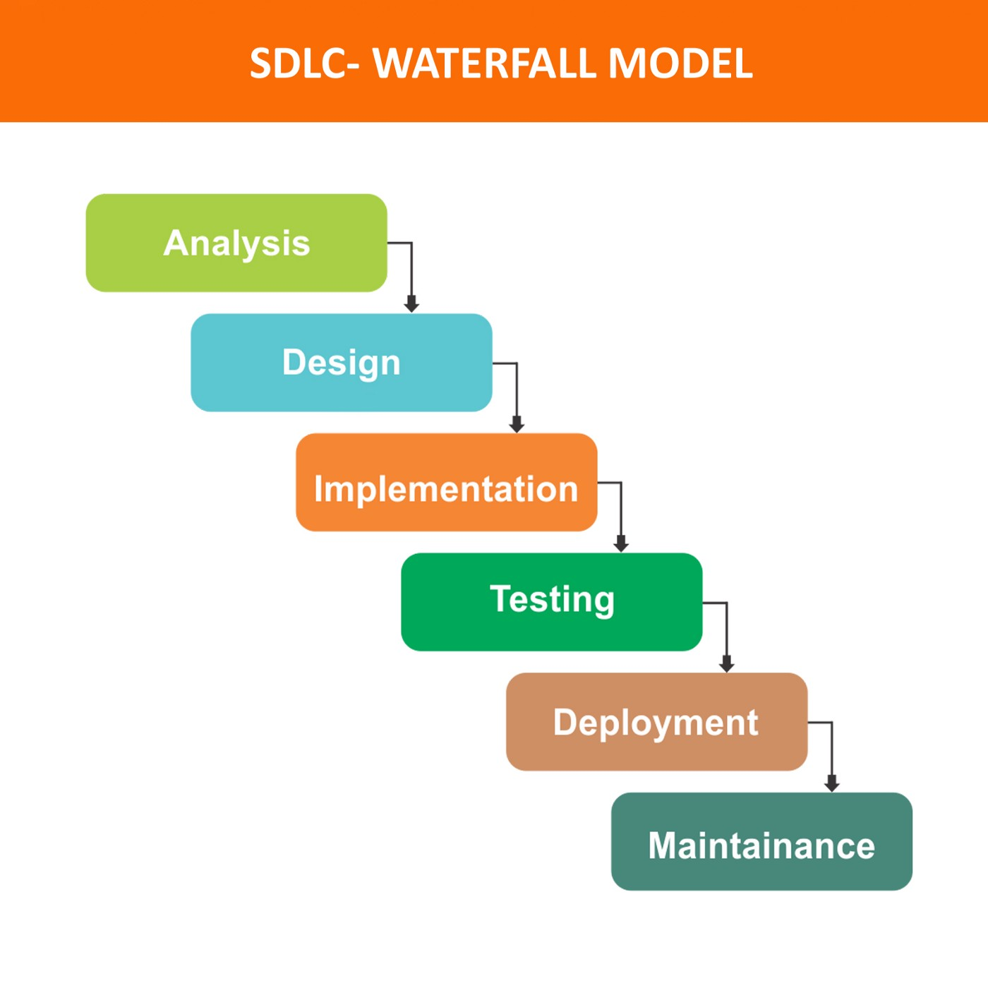

Berikut ini adalah tahapan model *Waterfall*:

1. **Requirement Gathering and analysis** — Mengumpulkan kebutuhan secara lengkap kemudian dianalisis dan didefinisikan kebutuhan yang harus dipenuhi oleh program yang akan dibangun. Fase ini harus dikerjakan secara lengkap untuk bisa menghasilkan desain yang lengkap.
2. **Desain**,dalam tahap ini pengembang akan menghasilkan sebuah sistem secara keseluruhan dan menentukan alur perangkat lunak hingga algoritma yang detail.
3. **Implementasi**adalah Tahapan dimana seluruh desain diubah menjadi kode kode progam . Kode progam yang dihasilkan masih berupa modul-modul yang akan diintregasikan menjadi sistem yang lengkap.
4. ***Integration&Testing***Di tahap ini dilakukan penggabungan modul-modul yang sudah dibuat dan dilakukan pengujian ini dilakukan untuk mengetahui apakah *software*yang dibuat telah sesuai dengan desainnya dan fungsi pada *software* terdapat kesalahan atau tidak.
5. **Verifikasi**adalah klien atau pengguna menguji apakah sistem tersebut telah sesuai dengan yang disetujui.
6. ***Operation & Maintenance***yaitu instalasi dan proses perbaikan sistem sesuai yang disetujui.

**BAB II**

**SPESIFIKASI SOFTWARE**

**2.1 User/System Requirement**

**2.1.1 User Requirement**

Peserta dapat mengetahui skor yang ada pada game.

**2.1.2 System Requirement**

1. Peserta dapat melihat menu utama pada screen, kemudia memilih start atau exit.

2. Peserta dapat memilih tingkat kesulitan game.

3. Peserta dapat menjawab soal.

4. Pesera dapat mengetahui jawaban yang benar setelah menjawab soal.

**2.2 Pemodelan System**

**2.2.1 Usecase Diagram**

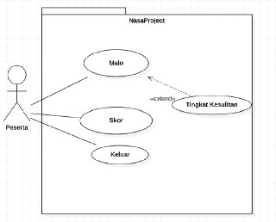

**2.2.2 Use Case Specification**

|  |
| --- |
| Nama Use Case: Main |
| Actor Utama: Peserta |
| Stakeholders and Interests:  Peserta – memainkan game |
| Brief Description: Use case ini mendeskripsikan tentang permainan yang dimainkan peserta. |
| Trigger: Peserta menekan tombol start.  Type: Internal |
| Relationships:  Association: Peserta  Include:  Extend: Tingkat Kesulitan  Generalization: Bermain game |
| Normal Flow of Events:   1. Peserta menekan tombol start. 2. Lalu peserta memilih tingkat kesulitan. 3. Peserta menjawab soal-soal yang diberikan. 4. Peserta akan melihat jawaban yang benar setelah menjawab. 5. Peserta akan menyelesaikan soal dan dapat melihat skor. |

|  |
| --- |
| Nama Use Case: Skor |
| Actor Utama: Peserta |
| Stakeholders and Interests:  Peserta – melihat skor |
| Brief Description: Use case ini mendeskripsikan tentang skor yang didapatkan peserta. |
| Trigger: Peserta menjawab soal.  Type: Internal |
| Relationships:  Association: Peserta  Include:  Extend:  Generalization: Skor game |
| Normal Flow of Events:   1. Peserta menekan tombol start. 2. Lalu peserta memilih tingkat kesulitan. 3. Peserta menjawab soal-soal yang diberikan. 4. Peserta akan melihat jawaban yang benar setelah menjawab. 5. Peserta akan menyelesaikan soal dan dapat melihat skor. |

|  |
| --- |
| Nama Use Case: Keluar |
| Actor Utama: Peserta |
| Stakeholders and Interests:  Peserta – menghentikan permainan |
| Brief Description: Use case ini mendeskripsikan tentang permainan yang dihentikan peserta. |
| Trigger: Peserta menekan tombol exit.  Type: Internal |
| Relationships:  Association: Peserta  Include:  Extend:  Generalization: Berhenti bermain game |
| Normal Flow of Events:   1. Peserta menekan tombol start. 2. Lalu peserta memilih tingkat kesulitan. 3. Peserta menjawab soal-soal yang diberikan. 4. Peserta akan melihat jawaban yang benar setelah menjawab. 5. Peserta akan menyelesaikan soal dan dapat melihat skor. 6. Peserta menekan tombol exit untuk keluar. |

**2.2.3 Activity Diagram**

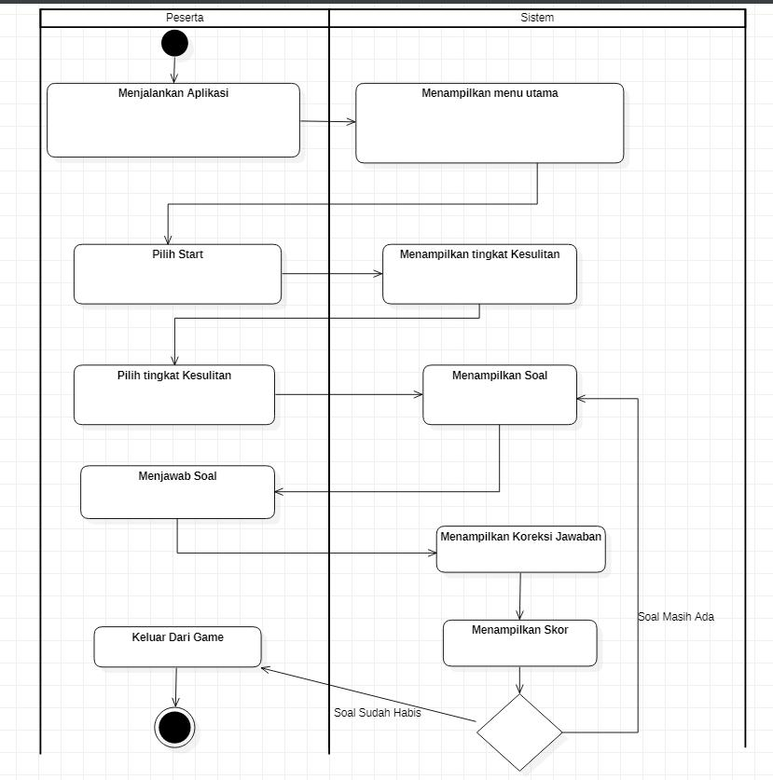

**2.2.4 Sequence Diagram**

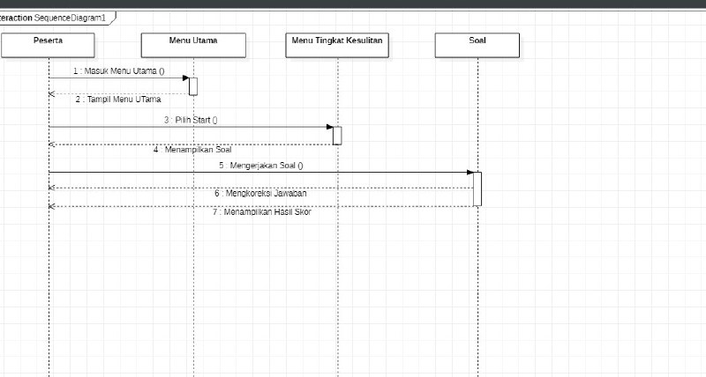

**2.2.5 Class Diagram**

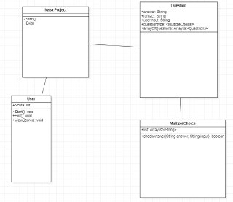

**BAB III**

**DESAIN & IMPLEMENTASI**

**3.1 Desain**

**3.1.1 Architectural Model**

**gameData**

**Requires Interface**

**Provides Interface**

**Data Collector**

**gameManagement**

**addSoal**

**checkAnswer**

**addSkor**

**showAnswer**

**ShowFunfact**

**3.1.2 Input**

Berikut ini beberapa input yang dilakukan user pada aplikasi The Earth :

1. Peserta memilih start atau exit.
2. Peserta memilih tingkat kesulitan soal.
3. Peserta menjawab soal.
   * 1. **Output**

Berikut ini beberapa output yang diperoleh user pada aplikasi The Earth :

1. Peserta mendapat jawaban yang benar.
2. Peserta dapat melihat skor.
3. Peserta dapat melihat funfact.

**3.2.1 Implementasi**

**3.2.1.1 Coding**

private void intermediatebutton_Click(object sender, EventArgs e)

{

difficultypanel.Hide();

questionpanel.Show();

qclass.Mode = "intermediate";

qclass.QuestionNumber = 1;

qclass.IntermediateLevel(qclass.QuestionNumber);

qnumber.Text = "Question (" + qclass.QuestionNumber + "/10)";

question.Text = qclass.Question;

mcqa.Text = mcqa.Text + qclass.AnswerA;

mcqb.Text = mcqb.Text + qclass.AnswerB;

mcqc.Text = mcqc.Text + qclass.AnswerC;

mcqd.Text = mcqd.Text + qclass.AnswerD;

}

private void expertbutton_Click(object sender, EventArgs e)

{

difficultypanel.Hide();

questionpanel.Show();

qclass.Mode = "expert";

qclass.QuestionNumber = 1;

qclass.ExpertLevel(qclass.QuestionNumber);

qnumber.Text = "Question (" + qclass.QuestionNumber + "/10)";

question.Text = qclass.Question;

mcqa.Text = mcqa.Text + qclass.AnswerA;

mcqb.Text = mcqb.Text + qclass.AnswerB;

mcqc.Text = mcqc.Text + qclass.AnswerC;

mcqd.Text = mcqd.Text + qclass.AnswerD;

}

}

private void startbutton_Click(object sender, EventArgs e)

{

startpanel.Hide();

difficultypanel.Show();

}

private void backstartbutton_Click(object sender, EventArgs e)

{

startpanel.Show();

difficultypanel.Hide();

}

QuestionClass qclass = new QuestionClass();

private void beginnerbutton_Click(object sender, EventArgs e)

{

difficultypanel.Hide();

questionpanel.Show();

qclass.Mode = "beginner";

qclass.QuestionNumber = 1;

qclass.BeginnerLevel(qclass.QuestionNumber);

qnumber.Text="Question ("+qclass.QuestionNumber+"/10)";

question.Text = qclass.Question;

mcqa.Text = mcqa.Text + qclass.AnswerA;

mcqb.Text = mcqb.Text + qclass.AnswerB;

mcqc.Text = mcqc.Text + qclass.AnswerC;

mcqd.Text = mcqd.Text + qclass.AnswerD;

}

**Form1.cs**

using System;

using System.Collections.Generic;

using System.ComponentModel;

using System.Data;

using System.Drawing;

using System.Linq;

using System.Text;

using System.Threading.Tasks;

using System.Windows.Forms;

namespace NasaProject

{

public partial class IndexForm : Form

{

public IndexForm()

{

InitializeComponent();

}

private void startbutton_MouseHover(object sender, EventArgs e)

{

startbutton.BackColor=Color.Transparent;

}

private void exitbutton_Click(object sender, EventArgs e)

{

DialogResult result = MessageBox.Show("Do you want to exit the game?", "Confirmation", MessageBoxButtons.YesNo, MessageBoxIcon.Question);

if (result == DialogResult.Yes)

{

this.Close();

}

else if (qclass.Mode == "expert")

{

qclass.ExpertCheckAnswer(mcqd.Text.Substring(3));

}

mcqd.Checked = false;

}

else

{

MessageBox.Show("Please answer all the question first!", "", MessageBoxButtons.OK, MessageBoxIcon.Exclamation);

}

}

scorelabel.Text = qclass.Score + "/100";

if (qclass.QuestionNumber < 10)

{

qclass.QuestionNumber = qclass.QuestionNumber + 1;

if (qclass.QuestionNumber == 3 || qclass.QuestionNumber == 6 || qclass.QuestionNumber == 9)

{

factlabel.Text = qclass.RandomFact();

factpanel.Show();

factpanel.BringToFront();

}

if (qclass.Mode == "beginner")

{

qclass.BeginnerLevel(qclass.QuestionNumber);

qnumber.Text = "Question (" + qclass.QuestionNumber + "/10)";

question.Text = qclass.Question;

mcqa.Text = "A. " + qclass.AnswerA;

mcqb.Text = "B. " + qclass.AnswerB;

mcqc.Text = "C. " + qclass.AnswerC;

mcqd.Text = "D. " + qclass.AnswerD;

}

else if (qclass.Mode == "intermediate")

qclass.IntermediaterCheckAnswer(mcqb.Text.Substring(3));

}

else if (qclass.Mode == "expert")

{

qclass.ExpertCheckAnswer(mcqb.Text.Substring(3));

}

mcqb.Checked = false;

}

else if (mcqc.Checked == true)

{

if (qclass.Mode == "beginner")

{

qclass.BeginnerCheckAnswer(mcqc.Text.Substring(3));

}

else if (qclass.Mode == "intermediate")

{

qclass.IntermediaterCheckAnswer(mcqc.Text.Substring(3));

}

else if (qclass.Mode == "expert")

{

qclass.ExpertCheckAnswer(mcqc.Text.Substring(3));

}

mcqc.Checked = false;

}

else if (mcqd.Checked == true)

{

if (qclass.Mode == "beginner")

{

qclass.BeginnerCheckAnswer(mcqd.Text.Substring(3));

}

else if (qclass.Mode == "intermediate")

{

qclass.IntermediaterCheckAnswer(mcqd.Text.Substring(3));

}

private void button1_Click(object sender, EventArgs e)

{

questionpanel.Hide();

difficultypanel.Show();

}

private void button2_Click(object sender, EventArgs e)

{

if (qclass.QuestionNumber <= 10)

{

if (mcqa.Checked == true)

{

if (qclass.Mode == "beginner")

{

qclass.BeginnerCheckAnswer(mcqa.Text.Substring(3));

}

else if (qclass.Mode == "intermediate")

{

qclass.IntermediaterCheckAnswer(mcqa.Text.Substring(3));

}

else if (qclass.Mode == "expert")

{

qclass.ExpertCheckAnswer(mcqa.Text.Substring(3));

}

mcqa.Checked = false;

}

else if (mcqb.Checked == true)

{

if (qclass.Mode == "beginner")

{

qclass.BeginnerCheckAnswer(mcqb.Text.Substring(3));

}

else if (qclass.Mode == "intermediate")

{

{

qclass.IntermediateLevel(qclass.QuestionNumber);

qnumber.Text = "Question (" + qclass.QuestionNumber + "/10)";

question.Text = qclass.Question;

mcqa.Text = "A. " + qclass.AnswerA;

mcqb.Text = "B. " + qclass.AnswerB;

mcqc.Text = "C. " + qclass.AnswerC;

mcqd.Text = "D. " + qclass.AnswerD;

}

else if (qclass.Mode == "expert")

{

qclass.ExpertLevel(qclass.QuestionNumber);

qnumber.Text = "Question (" + qclass.QuestionNumber + "/10)";

question.Text = qclass.Question;

mcqa.Text = "A. " + qclass.AnswerA;

mcqb.Text = "B. " + qclass.AnswerB;

mcqc.Text = "C. " + qclass.AnswerC;

mcqd.Text = "D. " + qclass.AnswerD;

}

}

else

{

qclass.QuestionNumber = 1;

qclass.Score = 0;

MessageBox.Show("The " + qclass.Mode + " chapter is completed", "Level Completed", MessageBoxButtons.OK, MessageBoxIcon.Information);

questionpanel.Hide();

difficultypanel.Show();

}

}

private void backbutton_Click(object sender, EventArgs e)

{

factpanel.Hide();

}

}

}

// startpanel

//

this.startpanel.AutoSizeMode = System.Windows.Forms.AutoSizeMode.GrowAndShrink;

this.startpanel.BackgroundImage = ((System.Drawing.Image)(resources.GetObject("startpanel.BackgroundImage")));

this.startpanel.BackgroundImageLayout = System.Windows.Forms.ImageLayout.Stretch;

this.startpanel.ColumnCount = 3;

this.startpanel.ColumnStyles.Add(new System.Windows.Forms.ColumnStyle(System.Windows.Forms.SizeType.Percent, 22F));

this.startpanel.ColumnStyles.Add(new System.Windows.Forms.ColumnStyle(System.Windows.Forms.SizeType.Percent, 55.25F));

this.startpanel.ColumnStyles.Add(new System.Windows.Forms.ColumnStyle(System.Windows.Forms.SizeType.Percent, 22.75F));

this.startpanel.Controls.Add(this.titlelabel, 1, 0);

this.startpanel.Controls.Add(this.exitbutton, 1, 3);

this.startpanel.Controls.Add(this.startbutton, 1, 2);

this.startpanel.Dock = System.Windows.Forms.DockStyle.Fill;

this.startpanel.GrowStyle = System.Windows.Forms.TableLayoutPanelGrowStyle.FixedSize;

this.startpanel.Location = new System.Drawing.Point(0, 0);

this.startpanel.Name = "startpanel";

this.startpanel.RowCount = 4;

this.startpanel.RowStyles.Add(new System.Windows.Forms.RowStyle(System.Windows.Forms.SizeType.Percent, 29.00822F));

this.startpanel.RowStyles.Add(new System.Windows.Forms.RowStyle(System.Windows.Forms.SizeType.Percent, 20.88889F));

this.startpanel.RowStyles.Add(new System.Windows.Forms.RowStyle(System.Windows.Forms.SizeType.Percent, 20F));

this.startpanel.RowStyles.Add(new System.Windows.Forms.RowStyle(System.Windows.Forms.SizeType.Percent, 30F));

this.startpanel.Size = new System.Drawing.Size(800, 450);

this.startpanel.TabIndex = 3;

//

// titlelabel

//

this.titlelabel.Anchor = ((System.Windows.Forms.AnchorStyles)((System.Windows.Forms.AnchorStyles.Left | System.Windows.Forms.AnchorStyles.Right)));

this.titlelabel.BackColor = System.Drawing.Color.Transparent;

this.titlelabel.Font = new System.Drawing.Font("Modern No. 20", 60F, System.Drawing.FontStyle.Bold, System.Drawing.GraphicsUnit.Point, ((byte)(0)));

this.titlelabel.ForeColor = System.Drawing.Color.White;

this.titlelabel.Location = new System.Drawing.Point(179, 31);

this.titlelabel.Name = "titlelabel";

this.titlelabel.Size = new System.Drawing.Size(436, 67);

this.titlelabel.TabIndex = 1;

this.exitbutton = new System.Windows.Forms.Button();

this.startbutton = new System.Windows.Forms.Button();

this.difficultypanel = new System.Windows.Forms.TableLayoutPanel();

this.expertbutton1 = new System.Windows.Forms.Button();

this.intermediatebutton1 = new System.Windows.Forms.Button();

this.expertbutton = new System.Windows.Forms.Button();

this.intermediatebutton = new System.Windows.Forms.Button();

this.backstartbutton = new System.Windows.Forms.Button();

this.selectdifficultylabel = new System.Windows.Forms.Label();

this.beginnerbutton = new System.Windows.Forms.Button();

this.beginnerbutton1 = new System.Windows.Forms.Button();

this.questionpanel = new System.Windows.Forms.TableLayoutPanel();

this.qnumber = new System.Windows.Forms.Label();

this.button1 = new System.Windows.Forms.Button();

this.mcqb = new System.Windows.Forms.RadioButton();

this.mcqd = new System.Windows.Forms.RadioButton();

this.mcqa = new System.Windows.Forms.RadioButton();

this.mcqc = new System.Windows.Forms.RadioButton();

this.question = new System.Windows.Forms.Label();

this.button2 = new System.Windows.Forms.Button();

this.factpanel = new System.Windows.Forms.TableLayoutPanel();

this.label1 = new System.Windows.Forms.Label();

this.factlabel = new System.Windows.Forms.Label();

this.backbutton = new System.Windows.Forms.Button();

this.panel1 = new System.Windows.Forms.Panel();

this.pictureBox1 = new System.Windows.Forms.PictureBox();

this.scorelabel = new System.Windows.Forms.Label();

this.startpanel.SuspendLayout();

this.difficultypanel.SuspendLayout();

this.questionpanel.SuspendLayout();

this.factpanel.SuspendLayout();

this.panel1.SuspendLayout();

((System.ComponentModel.ISupportInitialize)(this.pictureBox1)).BeginInit();

this.SuspendLayout();

//

**Form1.Designer.cs**

namespace NasaProject

{

partial class IndexForm

{

/// <summary>

/// Required designer variable.

/// </summary>

private System.ComponentModel.IContainer components = null;

/// <summary>

/// Clean up any resources being used.

/// </summary>

/// <param name="disposing">true if managed resources should be disposed; otherwise, false.</param>

protected override void Dispose(bool disposing)

{

if (disposing && (components != null))

{

components.Dispose();

}

base.Dispose(disposing);

}

#region Windows Form Designer generated code

/// <summary>

/// Required method for Designer support - do not modify

/// the contents of this method with the code editor.

/// </summary>

private void InitializeComponent()

{

System.ComponentModel.ComponentResourceManager resources = new System.ComponentModel.ComponentResourceManager(typeof(IndexForm));

this.startpanel = new System.Windows.Forms.TableLayoutPanel();

this.titlelabel = new System.Windows.Forms.Label();

//

// expertbutton1

//

this.expertbutton1.Anchor = System.Windows.Forms.AnchorStyles.Top;

this.expertbutton1.AutoSize = true;

this.expertbutton1.FlatAppearance.BorderSize = 0;

this.expertbutton1.FlatAppearance.MouseOverBackColor = System.Drawing.Color.Transparent;

this.expertbutton1.FlatStyle = System.Windows.Forms.FlatStyle.Flat;

this.expertbutton1.Font = new System.Drawing.Font("Poor Richard", 20.25F, System.Drawing.FontStyle.Regular, System.Drawing.GraphicsUnit.Point, ((byte)(0)));

this.expertbutton1.ForeColor = System.Drawing.Color.White;

this.expertbutton1.Location = new System.Drawing.Point(578, 329);

this.expertbutton1.Margin = new System.Windows.Forms.Padding(3, 3, 85, 3);

this.expertbutton1.Name = "expertbutton1";

this.expertbutton1.Size = new System.Drawing.Size(90, 41);

this.expertbutton1.TabIndex = 6;

this.expertbutton1.Text = "Expert";

this.expertbutton1.UseVisualStyleBackColor = true;

//

// intermediatebutton1

//

this.intermediatebutton1.Anchor = System.Windows.Forms.AnchorStyles.Top;

this.intermediatebutton1.AutoSize = true;

this.intermediatebutton1.FlatAppearance.BorderSize = 0;

this.intermediatebutton1.FlatAppearance.MouseOverBackColor = System.Drawing.Color.Transparent;

this.intermediatebutton1.FlatStyle = System.Windows.Forms.FlatStyle.Flat;

this.intermediatebutton1.Font = new System.Drawing.Font("Poor Richard", 20.25F, System.Drawing.FontStyle.Regular, System.Drawing.GraphicsUnit.Point, ((byte)(0)));

this.intermediatebutton1.ForeColor = System.Drawing.Color.White;

this.intermediatebutton1.Location = new System.Drawing.Point(318, 329);

this.intermediatebutton1.Name = "intermediatebutton1";

this.intermediatebutton1.Size = new System.Drawing.Size(155, 41);

this.intermediatebutton1.TabIndex = 5;

this.intermediatebutton1.Text = "Intermediate";

this.intermediatebutton1.UseVisualStyleBackColor = true;

//

this.startbutton.TabIndex = 2;

this.startbutton.Text = "Start";

this.startbutton.UseVisualStyleBackColor = false;

this.startbutton.Click += new System.EventHandler(this.startbutton_Click);

this.startbutton.MouseHover += new System.EventHandler(this.startbutton_MouseHover);

//

// difficultypanel

//

this.difficultypanel.AutoSizeMode = System.Windows.Forms.AutoSizeMode.GrowAndShrink;

this.difficultypanel.BackColor = System.Drawing.Color.Transparent;

this.difficultypanel.BackgroundImage = ((System.Drawing.Image)(resources.GetObject("difficultypanel.BackgroundImage")));

this.difficultypanel.BackgroundImageLayout = System.Windows.Forms.ImageLayout.Stretch;

this.difficultypanel.ColumnCount = 3;

this.difficultypanel.ColumnStyles.Add(new System.Windows.Forms.ColumnStyle(System.Windows.Forms.SizeType.Percent, 33F));

this.difficultypanel.ColumnStyles.Add(new System.Windows.Forms.ColumnStyle(System.Windows.Forms.SizeType.Percent, 33F));

this.difficultypanel.ColumnStyles.Add(new System.Windows.Forms.ColumnStyle(System.Windows.Forms.SizeType.Percent, 34F));

this.difficultypanel.Controls.Add(this.expertbutton1, 2, 2);

this.difficultypanel.Controls.Add(this.intermediatebutton1, 1, 2);

this.difficultypanel.Controls.Add(this.expertbutton, 2, 1);

this.difficultypanel.Controls.Add(this.intermediatebutton, 1, 1);

this.difficultypanel.Controls.Add(this.backstartbutton, 0, 0);

this.difficultypanel.Controls.Add(this.selectdifficultylabel, 1, 0);

this.difficultypanel.Controls.Add(this.beginnerbutton, 0, 1);

this.difficultypanel.Controls.Add(this.beginnerbutton1, 0, 2);

this.difficultypanel.Dock = System.Windows.Forms.DockStyle.Fill;

this.difficultypanel.GrowStyle = System.Windows.Forms.TableLayoutPanelGrowStyle.FixedSize;

this.difficultypanel.Location = new System.Drawing.Point(0, 0);

this.difficultypanel.Name = "difficultypanel";

this.difficultypanel.RowCount = 4;

this.difficultypanel.RowStyles.Add(new System.Windows.Forms.RowStyle(System.Windows.Forms.SizeType.Percent, 27.38095F));

this.difficultypanel.RowStyles.Add(new System.Windows.Forms.RowStyle(System.Windows.Forms.SizeType.Percent, 48.66667F));

this.difficultypanel.RowStyles.Add(new System.Windows.Forms.RowStyle(System.Windows.Forms.SizeType.Percent, 24F));

this.difficultypanel.RowStyles.Add(new System.Windows.Forms.RowStyle(System.Windows.Forms.SizeType.Absolute, 20F));

this.difficultypanel.Size = new System.Drawing.Size(800, 450);

this.difficultypanel.TabIndex = 4;

this.titlelabel.Text = "The Earth";

this.titlelabel.TextAlign = System.Drawing.ContentAlignment.MiddleCenter;

//

// exitbutton

//

this.exitbutton.Anchor = System.Windows.Forms.AnchorStyles.None;

this.exitbutton.BackColor = System.Drawing.Color.Black;

this.exitbutton.Cursor = System.Windows.Forms.Cursors.Hand;

this.exitbutton.FlatAppearance.BorderColor = System.Drawing.Color.Black;

this.exitbutton.FlatAppearance.MouseOverBackColor = System.Drawing.Color.Gray;

this.exitbutton.FlatStyle = System.Windows.Forms.FlatStyle.Popup;

this.exitbutton.Font = new System.Drawing.Font("Microsoft Sans Serif", 8.25F, System.Drawing.FontStyle.Bold, System.Drawing.GraphicsUnit.Point, ((byte)(0)));

this.exitbutton.ForeColor = System.Drawing.Color.White;

this.exitbutton.Location = new System.Drawing.Point(347, 364);

this.exitbutton.Name = "exitbutton";

this.exitbutton.Size = new System.Drawing.Size(100, 36);

this.exitbutton.TabIndex = 0;

this.exitbutton.Text = "Exit Game";

this.exitbutton.UseVisualStyleBackColor = false;

this.exitbutton.Click += new System.EventHandler(this.exitbutton_Click);

//

// startbutton

//

this.startbutton.Anchor = System.Windows.Forms.AnchorStyles.None;

this.startbutton.BackColor = System.Drawing.Color.Transparent;

this.startbutton.Cursor = System.Windows.Forms.Cursors.Hand;

this.startbutton.FlatAppearance.BorderSize = 0;

this.startbutton.FlatAppearance.MouseOverBackColor = System.Drawing.Color.Transparent;

this.startbutton.FlatStyle = System.Windows.Forms.FlatStyle.Flat;

this.startbutton.Font = new System.Drawing.Font("Poor Richard", 36F, System.Drawing.FontStyle.Bold, System.Drawing.GraphicsUnit.Point, ((byte)(0)));

this.startbutton.ForeColor = System.Drawing.SystemColors.Window;

this.startbutton.Location = new System.Drawing.Point(297, 239);

this.startbutton.Name = "startbutton";

this.startbutton.Size = new System.Drawing.Size(200, 60);

this.beginnerbutton.BackgroundImage = ((System.Drawing.Image)(resources.GetObject("beginnerbutton.BackgroundImage")));

this.beginnerbutton.BackgroundImageLayout = System.Windows.Forms.ImageLayout.Stretch;

this.beginnerbutton.Cursor = System.Windows.Forms.Cursors.Hand;

this.beginnerbutton.FlatStyle = System.Windows.Forms.FlatStyle.Flat;

this.beginnerbutton.ImageIndex = 0;

this.beginnerbutton.Location = new System.Drawing.Point(85, 124);

this.beginnerbutton.Margin = new System.Windows.Forms.Padding(60, 3, 3, 3);

this.beginnerbutton.Name = "beginnerbutton";

this.beginnerbutton.Size = new System.Drawing.Size(151, 194);

this.beginnerbutton.TabIndex = 0;

this.beginnerbutton.TextImageRelation = System.Windows.Forms.TextImageRelation.ImageAboveText;

this.beginnerbutton.UseVisualStyleBackColor = true;

this.beginnerbutton.Click += new System.EventHandler(this.beginnerbutton_Click);

//

// beginnerbutton1

//

this.beginnerbutton1.Anchor = System.Windows.Forms.AnchorStyles.Top;

this.beginnerbutton1.AutoSize = true;

this.beginnerbutton1.FlatAppearance.BorderSize = 0;

this.beginnerbutton1.FlatAppearance.MouseOverBackColor = System.Drawing.Color.Transparent;

this.beginnerbutton1.FlatStyle = System.Windows.Forms.FlatStyle.Flat;

this.beginnerbutton1.Font = new System.Drawing.Font("Poor Richard", 20.25F, System.Drawing.FontStyle.Regular, System.Drawing.GraphicsUnit.Point, ((byte)(0)));

this.beginnerbutton1.ForeColor = System.Drawing.Color.White;

this.beginnerbutton1.Location = new System.Drawing.Point(101, 329);

this.beginnerbutton1.Margin = new System.Windows.Forms.Padding(60, 3, 3, 3);

this.beginnerbutton1.Name = "beginnerbutton1";

this.beginnerbutton1.Size = new System.Drawing.Size(119, 41);

this.beginnerbutton1.TabIndex = 4;

this.beginnerbutton1.Text = "Beginner";

this.beginnerbutton1.UseVisualStyleBackColor = true;

//

// questionpanel

//

this.questionpanel.BackgroundImage = ((System.Drawing.Image)(resources.GetObject("questionpanel.BackgroundImage")));

this.backstartbutton.AccessibleRole = System.Windows.Forms.AccessibleRole.SplitButton;

this.backstartbutton.BackColor = System.Drawing.Color.Transparent;

this.backstartbutton.BackgroundImage = ((System.Drawing.Image)(resources.GetObject("backstartbutton.BackgroundImage")));

this.backstartbutton.BackgroundImageLayout = System.Windows.Forms.ImageLayout.Stretch;

this.backstartbutton.Cursor = System.Windows.Forms.Cursors.Hand;

this.backstartbutton.FlatAppearance.BorderSize = 0;

this.backstartbutton.FlatAppearance.MouseOverBackColor = System.Drawing.Color.Transparent;

this.backstartbutton.FlatStyle = System.Windows.Forms.FlatStyle.Flat;

this.backstartbutton.Font = new System.Drawing.Font("Microsoft Sans Serif", 8.25F, System.Drawing.FontStyle.Bold, System.Drawing.GraphicsUnit.Point, ((byte)(0)));

this.backstartbutton.ForeColor = System.Drawing.Color.White;

this.backstartbutton.Location = new System.Drawing.Point(20, 20);

this.backstartbutton.Margin = new System.Windows.Forms.Padding(20, 20, 3, 3);

this.backstartbutton.Name = "backstartbutton";

this.backstartbutton.Size = new System.Drawing.Size(60, 60);

this.backstartbutton.TabIndex = 1;

this.backstartbutton.UseVisualStyleBackColor = false;

this.backstartbutton.Click += new System.EventHandler(this.backstartbutton_Click);

//

// selectdifficultylabel

//

this.difficultypanel.SetColumnSpan(this.selectdifficultylabel, 2);

this.selectdifficultylabel.Dock = System.Windows.Forms.DockStyle.Left;

this.selectdifficultylabel.Font = new System.Drawing.Font("Modern No. 20", 36F, System.Drawing.FontStyle.Bold, System.Drawing.GraphicsUnit.Point, ((byte)(0)));

this.selectdifficultylabel.ForeColor = System.Drawing.Color.White;

this.selectdifficultylabel.Location = new System.Drawing.Point(267, 0);

this.selectdifficultylabel.Name = "selectdifficultylabel";

this.selectdifficultylabel.Size = new System.Drawing.Size(366, 117);

this.selectdifficultylabel.TabIndex = 0;

this.selectdifficultylabel.Text = "Select Difficulty";

this.selectdifficultylabel.TextAlign = System.Drawing.ContentAlignment.MiddleCenter;

//

// beginnerbutton

//

this.beginnerbutton.Anchor = System.Windows.Forms.AnchorStyles.None;

// expertbutton

//

this.expertbutton.Anchor = System.Windows.Forms.AnchorStyles.None;

this.expertbutton.BackgroundImage = ((System.Drawing.Image)(resources.GetObject("expertbutton.BackgroundImage")));

this.expertbutton.BackgroundImageLayout = System.Windows.Forms.ImageLayout.Stretch;

this.expertbutton.Cursor = System.Windows.Forms.Cursors.Hand;

this.expertbutton.FlatStyle = System.Windows.Forms.FlatStyle.Flat;

this.expertbutton.ImageIndex = 0;

this.expertbutton.Location = new System.Drawing.Point(560, 123);

this.expertbutton.Margin = new System.Windows.Forms.Padding(3, 3, 60, 3);

this.expertbutton.Name = "expertbutton";

this.expertbutton.Size = new System.Drawing.Size(150, 196);

this.expertbutton.TabIndex = 3;

this.expertbutton.TextImageRelation = System.Windows.Forms.TextImageRelation.ImageAboveText;

this.expertbutton.UseVisualStyleBackColor = true;

this.expertbutton.Click += new System.EventHandler(this.expertbutton_Click);

//

// intermediatebutton

//

this.intermediatebutton.Anchor = System.Windows.Forms.AnchorStyles.None;

this.intermediatebutton.BackgroundImage = ((System.Drawing.Image)(resources.GetObject("intermediatebutton.BackgroundImage")));

this.intermediatebutton.BackgroundImageLayout = System.Windows.Forms.ImageLayout.Stretch;

this.intermediatebutton.Cursor = System.Windows.Forms.Cursors.Hand;

this.intermediatebutton.FlatStyle = System.Windows.Forms.FlatStyle.Flat;

this.intermediatebutton.ImageIndex = 0;

this.intermediatebutton.Location = new System.Drawing.Point(318, 126);

this.intermediatebutton.Name = "intermediatebutton";

this.intermediatebutton.Size = new System.Drawing.Size(156, 191);

this.intermediatebutton.TabIndex = 2;

this.intermediatebutton.TextImageRelation = System.Windows.Forms.TextImageRelation.ImageAboveText;

this.intermediatebutton.UseVisualStyleBackColor = true;

this.intermediatebutton.Click += new System.EventHandler(this.intermediatebutton_Click);

//

// backstartbutton

//

this.mcqb.Name = "mcqb";

this.mcqb.Size = new System.Drawing.Size(53, 32);

this.mcqb.TabIndex = 5;

this.mcqb.TabStop = true;

this.mcqb.Text = "B. ";

this.mcqb.UseVisualStyleBackColor = false;

//

// mcqd

//

this.mcqd.AutoSize = true;

this.mcqd.BackColor = System.Drawing.Color.Transparent;

this.mcqd.Font = new System.Drawing.Font("Poor Richard", 18F, System.Drawing.FontStyle.Regular, System.Drawing.GraphicsUnit.Point, ((byte)(0)));

this.mcqd.ForeColor = System.Drawing.Color.White;

this.mcqd.Location = new System.Drawing.Point(403, 339);

this.mcqd.Name = "mcqd";

this.mcqd.Size = new System.Drawing.Size(54, 32);

this.mcqd.TabIndex = 6;

this.mcqd.TabStop = true;

this.mcqd.Text = "D. ";

this.mcqd.UseVisualStyleBackColor = false;

//

// mcqa

//

this.mcqa.AutoSize = true;

this.mcqa.BackColor = System.Drawing.Color.Transparent;

this.mcqa.Font = new System.Drawing.Font("Poor Richard", 18F, System.Drawing.FontStyle.Regular, System.Drawing.GraphicsUnit.Point, ((byte)(0)));

this.mcqa.ForeColor = System.Drawing.Color.White;

this.mcqa.Location = new System.Drawing.Point(203, 227);

this.mcqa.Name = "mcqa";

this.mcqa.Size = new System.Drawing.Size(55, 32);

this.mcqa.TabIndex = 7;

this.mcqa.TabStop = true;

this.mcqa.Text = "A. ";

this.qnumber.Location = new System.Drawing.Point(300, 31);

this.qnumber.Name = "qnumber";

this.qnumber.Size = new System.Drawing.Size(200, 50);

this.qnumber.TabIndex = 3;

this.qnumber.Text = "Question";

this.qnumber.TextAlign = System.Drawing.ContentAlignment.MiddleCenter;

//

// button1

//

this.button1.AccessibleRole = System.Windows.Forms.AccessibleRole.SplitButton;

this.button1.BackColor = System.Drawing.Color.Transparent;

this.button1.BackgroundImage = ((System.Drawing.Image)(resources.GetObject("button1.BackgroundImage")));

this.button1.BackgroundImageLayout = System.Windows.Forms.ImageLayout.Stretch;

this.button1.Cursor = System.Windows.Forms.Cursors.Hand;

this.button1.FlatAppearance.BorderSize = 0;

this.button1.FlatAppearance.MouseOverBackColor = System.Drawing.Color.Transparent;

this.button1.FlatStyle = System.Windows.Forms.FlatStyle.Flat;

this.button1.Font = new System.Drawing.Font("Microsoft Sans Serif", 8.25F, System.Drawing.FontStyle.Bold, System.Drawing.GraphicsUnit.Point, ((byte)(0)));

this.button1.ForeColor = System.Drawing.Color.White;

this.button1.Location = new System.Drawing.Point(20, 20);

this.button1.Margin = new System.Windows.Forms.Padding(20, 20, 3, 3);

this.button1.Name = "button1";

this.button1.Size = new System.Drawing.Size(60, 60);

this.button1.TabIndex = 2;

this.button1.UseVisualStyleBackColor = false;

this.button1.Click += new System.EventHandler(this.button1_Click);

//

// mcqb

//

this.mcqb.AutoSize = true;

this.mcqb.BackColor = System.Drawing.Color.Transparent;

this.mcqb.Font = new System.Drawing.Font("Poor Richard", 18F, System.Drawing.FontStyle.Regular, System.Drawing.GraphicsUnit.Point, ((byte)(0)));

this.mcqb.ForeColor = System.Drawing.Color.White;

this.mcqb.Location = new System.Drawing.Point(403, 227);

this.questionpanel.BackgroundImageLayout = System.Windows.Forms.ImageLayout.Stretch;

this.questionpanel.ColumnCount = 4;

this.questionpanel.ColumnStyles.Add(new System.Windows.Forms.ColumnStyle(System.Windows.Forms.SizeType.Percent, 25F));

this.questionpanel.ColumnStyles.Add(new System.Windows.Forms.ColumnStyle(System.Windows.Forms.SizeType.Percent, 25F));

this.questionpanel.ColumnStyles.Add(new System.Windows.Forms.ColumnStyle(System.Windows.Forms.SizeType.Percent, 25F));

this.questionpanel.ColumnStyles.Add(new System.Windows.Forms.ColumnStyle(System.Windows.Forms.SizeType.Percent, 25F));

this.questionpanel.Controls.Add(this.qnumber, 1, 0);

this.questionpanel.Controls.Add(this.button1, 0, 0);

this.questionpanel.Controls.Add(this.mcqb, 2, 2);

this.questionpanel.Controls.Add(this.mcqd, 2, 3);

this.questionpanel.Controls.Add(this.mcqa, 1, 2);

this.questionpanel.Controls.Add(this.mcqc, 1, 3);

this.questionpanel.Controls.Add(this.question, 1, 1);

this.questionpanel.Controls.Add(this.button2, 3, 3);

this.questionpanel.Controls.Add(this.panel1, 3, 0);

this.questionpanel.Dock = System.Windows.Forms.DockStyle.Fill;

this.questionpanel.Location = new System.Drawing.Point(0, 0);

this.questionpanel.Name = "questionpanel";

this.questionpanel.RowCount = 4;

this.questionpanel.RowStyles.Add(new System.Windows.Forms.RowStyle(System.Windows.Forms.SizeType.Percent, 25F));

this.questionpanel.RowStyles.Add(new System.Windows.Forms.RowStyle(System.Windows.Forms.SizeType.Percent, 25F));

this.questionpanel.RowStyles.Add(new System.Windows.Forms.RowStyle(System.Windows.Forms.SizeType.Percent, 25F));

this.questionpanel.RowStyles.Add(new System.Windows.Forms.RowStyle(System.Windows.Forms.SizeType.Percent, 25F));

this.questionpanel.Size = new System.Drawing.Size(800, 450);

this.questionpanel.TabIndex = 7;

//

// qnumber

//

this.qnumber.Anchor = System.Windows.Forms.AnchorStyles.None;

this.qnumber.AutoSize = true;

this.qnumber.BackColor = System.Drawing.Color.Transparent;

this.questionpanel.SetColumnSpan(this.qnumber, 2);

this.qnumber.Font = new System.Drawing.Font("Modern No. 20", 36F, System.Drawing.FontStyle.Bold, System.Drawing.GraphicsUnit.Point, ((byte)(0)));

this.qnumber.ForeColor = System.Drawing.Color.White;

this.label1.Anchor = System.Windows.Forms.AnchorStyles.None;

this.label1.AutoSize = true;

this.label1.BackColor = System.Drawing.Color.Transparent;

this.label1.FlatStyle = System.Windows.Forms.FlatStyle.Flat;

this.label1.Font = new System.Drawing.Font("Modern No. 20", 60F, System.Drawing.FontStyle.Bold, System.Drawing.GraphicsUnit.Point, ((byte)(0)));

this.label1.ForeColor = System.Drawing.Color.White;

this.label1.Location = new System.Drawing.Point(135, 6);

this.label1.Name = "label1";

this.label1.Size = new System.Drawing.Size(530, 83);

this.label1.TabIndex = 0;

this.label1.Text = "Did you know?";

//

// factlabel

//

this.factlabel.Anchor = System.Windows.Forms.AnchorStyles.Top;

this.factlabel.AutoSize = true;

this.factlabel.BackColor = System.Drawing.Color.Transparent;

this.factlabel.FlatStyle = System.Windows.Forms.FlatStyle.Flat;

this.factlabel.Font = new System.Drawing.Font("Poor Richard", 27.75F, System.Drawing.FontStyle.Regular, System.Drawing.GraphicsUnit.Point, ((byte)(0)));

this.factlabel.ForeColor = System.Drawing.Color.White;

this.factlabel.Location = new System.Drawing.Point(324, 126);

this.factlabel.Margin = new System.Windows.Forms.Padding(3, 30, 3, 0);

this.factlabel.MaximumSize = new System.Drawing.Size(350, 0);

this.factlabel.Name = "factlabel";

this.factlabel.Size = new System.Drawing.Size(152, 44);

this.factlabel.TabIndex = 1;

this.factlabel.Text = "facts here";

this.factlabel.TextAlign = System.Drawing.ContentAlignment.MiddleCenter;

//

// backbutton

//

this.backbutton.Anchor = System.Windows.Forms.AnchorStyles.None;

this.backbutton.BackColor = System.Drawing.Color.Black;

this.button2.Anchor = System.Windows.Forms.AnchorStyles.Right;

this.button2.BackColor = System.Drawing.Color.Transparent;

this.button2.BackgroundImage = ((System.Drawing.Image)(resources.GetObject("button2.BackgroundImage")));

this.button2.BackgroundImageLayout = System.Windows.Forms.ImageLayout.Stretch;

this.button2.FlatStyle = System.Windows.Forms.FlatStyle.Flat;

this.button2.Location = new System.Drawing.Point(690, 368);

this.button2.Margin = new System.Windows.Forms.Padding(3, 3, 50, 3);

this.button2.Name = "button2";

this.button2.Size = new System.Drawing.Size(60, 50);

this.button2.TabIndex = 10;

this.button2.UseVisualStyleBackColor = false;

this.button2.Click += new System.EventHandler(this.button2_Click);

//

// factpanel

//

this.factpanel.BackgroundImage = ((System.Drawing.Image)(resources.GetObject("factpanel.BackgroundImage")));

this.factpanel.BackgroundImageLayout = System.Windows.Forms.ImageLayout.Stretch;

this.factpanel.ColumnCount = 1;

this.factpanel.ColumnStyles.Add(new System.Windows.Forms.ColumnStyle(System.Windows.Forms.SizeType.Percent, 100F));

this.factpanel.ColumnStyles.Add(new System.Windows.Forms.ColumnStyle(System.Windows.Forms.SizeType.Absolute, 20F));

this.factpanel.Controls.Add(this.backbutton, 0, 2);

this.factpanel.Controls.Add(this.label1, 0, 0);

this.factpanel.Controls.Add(this.factlabel, 0, 1);

this.factpanel.Dock = System.Windows.Forms.DockStyle.Fill;

this.factpanel.Location = new System.Drawing.Point(0, 0);

this.factpanel.Name = "factpanel";

this.factpanel.RowCount = 3;

this.factpanel.RowStyles.Add(new System.Windows.Forms.RowStyle(System.Windows.Forms.SizeType.Percent, 21.55556F));

this.factpanel.RowStyles.Add(new System.Windows.Forms.RowStyle(System.Windows.Forms.SizeType.Percent, 63.77778F));

this.factpanel.RowStyles.Add(new System.Windows.Forms.RowStyle(System.Windows.Forms.SizeType.Percent, 14.88889F));

this.factpanel.Size = new System.Drawing.Size(800, 450);

this.factpanel.TabIndex = 8;

//

// label1

//

this.mcqa.UseVisualStyleBackColor = false;

//

// mcqc

//

this.mcqc.AutoSize = true;

this.mcqc.BackColor = System.Drawing.Color.Transparent;

this.mcqc.Font = new System.Drawing.Font("Poor Richard", 18F, System.Drawing.FontStyle.Regular, System.Drawing.GraphicsUnit.Point, ((byte)(0)));

this.mcqc.ForeColor = System.Drawing.Color.White;

this.mcqc.Location = new System.Drawing.Point(203, 339);

this.mcqc.Name = "mcqc";

this.mcqc.Size = new System.Drawing.Size(54, 32);

this.mcqc.TabIndex = 4;

this.mcqc.TabStop = true;

this.mcqc.Text = "C. ";

this.mcqc.UseVisualStyleBackColor = false;

//

// question

//

this.question.Anchor = System.Windows.Forms.AnchorStyles.Left;

this.question.AutoSize = true;

this.question.BackColor = System.Drawing.Color.Transparent;

this.questionpanel.SetColumnSpan(this.question, 2);

this.question.FlatStyle = System.Windows.Forms.FlatStyle.Flat;

this.question.Font = new System.Drawing.Font("Poor Richard", 30F, System.Drawing.FontStyle.Regular, System.Drawing.GraphicsUnit.Point, ((byte)(0)));

this.question.ForeColor = System.Drawing.Color.White;

this.question.Location = new System.Drawing.Point(203, 144);

this.question.Name = "question";

this.question.Size = new System.Drawing.Size(212, 47);

this.question.TabIndex = 8;

this.question.Text = "Tulis soal sini";

//

// button2

//

this.startpanel.ResumeLayout(false);

this.difficultypanel.ResumeLayout(false);

this.difficultypanel.PerformLayout();

this.questionpanel.ResumeLayout(false);

this.questionpanel.PerformLayout();

this.factpanel.ResumeLayout(false);

this.factpanel.PerformLayout();

this.panel1.ResumeLayout(false);

this.panel1.PerformLayout();

((System.ComponentModel.ISupportInitialize)(this.pictureBox1)).EndInit();

this.ResumeLayout(false);

}

#endregion

private System.Windows.Forms.TableLayoutPanel startpanel;

private System.Windows.Forms.Label titlelabel;

private System.Windows.Forms.Button exitbutton;

private System.Windows.Forms.Button startbutton;

private System.Windows.Forms.TableLayoutPanel difficultypanel;

private System.Windows.Forms.Label selectdifficultylabel;

private System.Windows.Forms.Button backstartbutton;

private System.Windows.Forms.Button expertbutton1;

private System.Windows.Forms.Button intermediatebutton1;

private System.Windows.Forms.Button expertbutton;

private System.Windows.Forms.Button intermediatebutton;

private System.Windows.Forms.Button beginnerbutton;

private System.Windows.Forms.Button beginnerbutton1;

private System.Windows.Forms.TableLayoutPanel questionpanel;

private System.Windows.Forms.Label qnumber;

private System.Windows.Forms.Button button1;

private System.Windows.Forms.RadioButton mcqb;

private System.Windows.Forms.RadioButton mcqd;

private System.Windows.Forms.RadioButton mcqa;

private System.Windows.Forms.RadioButton mcqc;

private System.Windows.Forms.Label question;

private System.Windows.Forms.Button button2;

private System.Windows.Forms.TableLayoutPanel factpanel;

private System.Windows.Forms.Button backbutton;

private System.Windows.Forms.Label label1;

private System.Windows.Forms.Label factlabel;

private System.Windows.Forms.Panel panel1;

private System.Windows.Forms.PictureBox pictureBox1;

private System.Windows.Forms.Label scorelabel;

}

}

this.pictureBox1.Size = new System.Drawing.Size(50, 50);

this.pictureBox1.SizeMode = System.Windows.Forms.PictureBoxSizeMode.AutoSize;

this.pictureBox1.TabIndex = 0;

this.pictureBox1.TabStop = false;

//

// scorelabel

//

this.scorelabel.Anchor = System.Windows.Forms.AnchorStyles.None;

this.scorelabel.BackColor = System.Drawing.Color.Transparent;

this.scorelabel.FlatStyle = System.Windows.Forms.FlatStyle.Flat;

this.scorelabel.Font = new System.Drawing.Font("Poor Richard", 21.75F, System.Drawing.FontStyle.Regular, System.Drawing.GraphicsUnit.Point, ((byte)(0)));

this.scorelabel.ForeColor = System.Drawing.Color.White;

this.scorelabel.Location = new System.Drawing.Point(68, 9);

this.scorelabel.Name = "scorelabel";

this.scorelabel.Size = new System.Drawing.Size(129, 50);

this.scorelabel.TabIndex = 1;

this.scorelabel.Text = "score";

this.scorelabel.TextAlign = System.Drawing.ContentAlignment.MiddleCenter;

//

// IndexForm

//

this.AutoScaleDimensions = new System.Drawing.SizeF(6F, 13F);

this.AutoScaleMode = System.Windows.Forms.AutoScaleMode.Font;

this.AutoSize = true;

this.ClientSize = new System.Drawing.Size(800, 450);

this.Controls.Add(this.startpanel);

this.Controls.Add(this.difficultypanel);

this.Controls.Add(this.questionpanel);

this.Controls.Add(this.factpanel);

this.FormBorderStyle = System.Windows.Forms.FormBorderStyle.None;

this.Name = "IndexForm";

this.StartPosition = System.Windows.Forms.FormStartPosition.CenterScreen;

this.Text = "Form1";

this.WindowState = System.Windows.Forms.FormWindowState.Maximized;

this.backbutton.Cursor = System.Windows.Forms.Cursors.Hand;

this.backbutton.FlatAppearance.BorderColor = System.Drawing.Color.Black;

this.backbutton.FlatAppearance.MouseOverBackColor = System.Drawing.Color.Gray;

this.backbutton.FlatStyle = System.Windows.Forms.FlatStyle.Popup;

this.backbutton.Font = new System.Drawing.Font("Microsoft Sans Serif", 8.25F, System.Drawing.FontStyle.Bold, System.Drawing.GraphicsUnit.Point, ((byte)(0)));

this.backbutton.ForeColor = System.Drawing.Color.White;

this.backbutton.Location = new System.Drawing.Point(350, 398);

this.backbutton.Name = "backbutton";

this.backbutton.Size = new System.Drawing.Size(100, 36);

this.backbutton.TabIndex = 2;

this.backbutton.Text = "back";

this.backbutton.UseVisualStyleBackColor = false;

this.backbutton.Click += new System.EventHandler(this.backbutton_Click);

//

// panel1

//

this.panel1.BackColor = System.Drawing.Color.Transparent;

this.panel1.Controls.Add(this.pictureBox1);

this.panel1.Controls.Add(this.scorelabel);

this.panel1.Dock = System.Windows.Forms.DockStyle.Fill;

this.panel1.Location = new System.Drawing.Point(603, 3);

this.panel1.Name = "panel1";

this.panel1.Size = new System.Drawing.Size(194, 106);

this.panel1.TabIndex = 11;

//

// pictureBox1

//

this.pictureBox1.Anchor = System.Windows.Forms.AnchorStyles.None;

this.pictureBox1.BackgroundImage = ((System.Drawing.Image)(resources.GetObject("pictureBox1.BackgroundImage")));

this.pictureBox1.BackgroundImageLayout = System.Windows.Forms.ImageLayout.Stretch;

this.pictureBox1.Location = new System.Drawing.Point(12, 9);

this.pictureBox1.Name = "pictureBox1";

<Reference Include="System.Net.Http" />

<Reference Include="System.Windows.Forms" />

<Reference Include="System.Xml" />

</ItemGroup>

<ItemGroup>

<Compile Include="Form1.cs">

<SubType>Form</SubType>

</Compile>

<Compile Include="Form1.Designer.cs">

<DependentUpon>Form1.cs</DependentUpon>

</Compile>

<Compile Include="Program.cs" />

<Compile Include="Properties\AssemblyInfo.cs" />

<Compile Include="QuestionClass.cs" />

<EmbeddedResource Include="Form1.resx">

<DependentUpon>Form1.cs</DependentUpon>

</EmbeddedResource>

<EmbeddedResource Include="Properties\Resources.resx">

<Generator>ResXFileCodeGenerator</Generator>

<LastGenOutput>Resources.Designer.cs</LastGenOutput>

<SubType>Designer</SubType>

</EmbeddedResource>

<Compile Include="Properties\Resources.Designer.cs">

<AutoGen>True</AutoGen>

<DependentUpon>Resources.resx</DependentUpon>

</Compile>

<None Include="Properties\Settings.settings">

<Generator>SettingsSingleFileGenerator</Generator>

<LastGenOutput>Settings.Designer.cs</LastGenOutput>

</None>

<Compile Include="Properties\Settings.Designer.cs">

<AutoGen>True</AutoGen>

<DependentUpon>Settings.settings</DependentUpon>

<DesignTimeSharedInput>True</DesignTimeSharedInput>

</Compile>

</ItemGroup>

<ItemGroup>

<None Include="App.config" />

</ItemGroup>

<Import Project="$(MSBuildToolsPath)\Microsoft.CSharp.targets" />

</Project>

**NasaProject.csproj**

<?xml version="1.0" encoding="utf-8"?>

<Project ToolsVersion="15.0" xmlns="http://schemas.microsoft.com/developer/msbuild/2003">

<Import Project="$(MSBuildExtensionsPath)\$(MSBuildToolsVersion)\Microsoft.Common.props" Condition="Exists('$(MSBuildExtensionsPath)\$(MSBuildToolsVersion)\Microsoft.Common.props')" />

<PropertyGroup>

<Configuration Condition=" '$(Configuration)' == '' ">Debug</Configuration>

<Platform Condition=" '$(Platform)' == '' ">AnyCPU</Platform>

<ProjectGuid>{093B95F3-00EE-4CCE-AC0F-FF93B734E566}</ProjectGuid>

<OutputType>WinExe</OutputType>

<RootNamespace>NasaProject</RootNamespace>

<AssemblyName>NasaProject</AssemblyName>

<TargetFrameworkVersion>v4.6.1</TargetFrameworkVersion>

<FileAlignment>512</FileAlignment>

<AutoGenerateBindingRedirects>true</AutoGenerateBindingRedirects>

<Deterministic>true</Deterministic>

</PropertyGroup>

<PropertyGroup Condition=" '$(Configuration)|$(Platform)' == 'Debug|AnyCPU' ">

<PlatformTarget>AnyCPU</PlatformTarget>

<DebugSymbols>true</DebugSymbols>

<DebugType>full</DebugType>

<Optimize>false</Optimize>

<OutputPath>bin\Debug\</OutputPath>

<DefineConstants>DEBUG;TRACE</DefineConstants>

<ErrorReport>prompt</ErrorReport>

<WarningLevel>4</WarningLevel>

</PropertyGroup>

<PropertyGroup Condition=" '$(Configuration)|$(Platform)' == 'Release|AnyCPU' ">

<PlatformTarget>AnyCPU</PlatformTarget>

<DebugType>pdbonly</DebugType>

<Optimize>true</Optimize>

<OutputPath>bin\Release\</OutputPath>

<DefineConstants>TRACE</DefineConstants>

<ErrorReport>prompt</ErrorReport>

<WarningLevel>4</WarningLevel>

</PropertyGroup>

<ItemGroup>

<Reference Include="System" />

<Reference Include="System.Core" />

<Reference Include="System.Xml.Linq" />

<Reference Include="System.Data.DataSetExtensions" />

<Reference Include="Microsoft.CSharp" />

<Reference Include="System.Data" />

<Reference Include="System.Deployment" />

<Reference Include="System.Drawing" />

**Program.cs**

using System;

using System.Collections.Generic;

using System.Linq;

using System.Threading.Tasks;

using System.Windows.Forms;

namespace NasaProject

{

static class Program

{

/// <summary>

/// The main entry point for the application.

/// </summary>

[STAThread]

static void Main()

{

Application.EnableVisualStyles();

Application.SetCompatibleTextRenderingDefault(false);

Application.Run(new IndexForm());

}

}

}

public string Mode

{

get

{

return mode;

}

set

{

mode = value;

}

}

public int Score

{

get

{

return score;

}

set

{

score = value;

}

}

public string Question

{

get

{

return question;

}

set

{

question = value;

}

}

public string AnswerA

{

get

{

return answera;

}

set

{

answera = value;

}

}

public string AnswerB

{

get

{

return answerb;

}

set

{

answerb = value;

}

}

public string AnswerC

{

get

{

return answerc;

}

set

{

answerc = value;

}

}

public string AnswerD

**QuestionClass.cs**

using System;

using System.Collections.Generic;

using System.Linq;

using System.Text;

using System.Threading.Tasks;

using System.Windows.Forms;

namespace NasaProject

{

class QuestionClass

{

private int questionnumber;

private string mode;

private string question;

private string answera;

private string answerb;

private string answerc;

private string answerd;

private string realanswer;

private string fact;

private int score;

public int QuestionNumber

{

get

{

return questionnumber;

}

set

{

questionnumber=value;

}

}

private string[,] beginnerquestion =new string[10,6] {

{"Earth rotates in about _____ hours","12", "24", "6", "26", "24"},

{"The Earth is the ______ planet from the Sun.", "Fifth", "Fourth", "Third", "Second", "Third"},

{"The highest mountain on the Earth, measured conventionally from sea level, is _________", "Mauna Kea", "K2", "Everest", "McKinley", "Everest"},

{"What is the name of the largest ocean on Earth?", "Pacific Ocean", "Atlantic Ocean", "Indian Ocean", "Arctic Ocean", "Pacific Ocean"},

{"What is the name of the largest river?", "The Amazon", "The Misssissippi", "The Nile", "The Ganges", "The Nile"},

{"Outside of Antarctica, what is the largest desert in the world?","Kalahari Desert","Sahara Desert","Arabian Desert","Great Victoria Desert", "Sahara Desert"},

{"70 percent of the Earth is covered with:","Water","Rock","Dessert","Ice", "Water"},

{"Size-wise the Earth ranks:","Fifth largest","Smallest","Largest","Third largest", "Fifth largest"},

{"What gas other than nitrogen is in our atmosphere?","Neon","Radon","Oxygen","Hydrogen", "Oxygen"},

{"What percentage of nitrogen is in our atmosphere?","78%","55%","3%","19%", "3%"}};

private string[,] intermediatequestion = new string[10, 6]{

{"Movement of the earth on its axis is called as _______.","Resolution","Cycle","Revolution","Rotation","Rotation"},

{"We can see Full moon once a month and that night is called as _______.", "Poornima", "Half Amavasy", " Half Poornim", "Amavasya", "Poornima"},

{"In ancient times, people used to determine directions during the night with the help of ______.", "Constellations", "Planets", "Stars", "Pole", "Stars"},

{"The ____ is in the centre of the solar system.", "Jupiter", "Venus", "Earth", "Sun", "Sun"},

{"Our solar system is a part of ________ galaxy.", "Pinwheel Galaxy", "Milky Way", " Cigar Galaxy", "Bode's Galaxy", "Milky Way"},

{"Neil Armstrong step on the surface of the moon on __________.", "29 July 1969","29 July 1949", "29 July 1979", "29 July 1959","29 July 1969"},

{"The value of the prime meridian is ________ degree.", "0", "90", "180", "270", "0"},

{"The diameter of earth is approximately ________", "6400 km", "4600 km", "12800 km", " 12800 km", "12800 km"},

{"Third layer of Earth which comes after Mantle of Earth is known as _______", "The Outer Core", "The Inner Core", "The Mantle", "The Crust", "The Outer Core"},

{"Two halves in which Earth is divided are called _______", "ridges", "trenches", "equators", "hemispheres", "trenches"} };

private string[,] expertquestion = new string[10, 6]{

{"Alps Mountains and Himalayas are classic example of process of ______", "Plate Owning", "Plate Tectonics", "Plate Convection", "Folding", "Folding"},

{"Lowest part of mantle is known as", "A-layer", "B-layer", "M-layer", "D-layer", "D-layer"},

{"What is the angle of inclination of Earth’s Axis to its orbital plane?", "66.5 Degree", "66.25 Degree", "23.5 Degree", "90 Degree", "66.5 Degree"},

{"When does the spring tide occur ?", "Moon is nearest to Earth", "Moon is farthest to Earth", "Moon sun and earth are perpendicular to each other", "Sun moon and earth are colinear", "Sun moon and earth are colinear"},

{"Where does the speed of rotation of Earth is highest?", "Along Equator", "At Both pole (North and South Pole)", "At Tropic cancer", "at Arctic Circle", "Along Equator"},

{"Degree of hardness of Minerals is measured by which of the following scale?", "Litho Scale", "Mohs’ Scale", "Aesthono Scale", "Sima Sclae", "Mohs’ Scale"},

{"What is the total surface of the earth?", "510 million square kilometer", "610 million square kilometer", "710 million square kilometer", "810 million square kilometer", "510 million square kilometer"},

{"On 22nd Dec, where does the day is longest and night is shortest?", "Beijing", "Melbourne", "Washington DC", "Chennai", "Melbourne"},

{"The height from the earth of Geostationary orbit is situated is ______", "36000 km", "62000 km", "22000 km", "43000 km", "36000"},

{"If moon is seen in a particular place on the sky at 6:48 p.m. When it will be seen on the same place on the sky after 4 days?", "At 10 PM", "At 10:48 PM", "At 9:28 PM", "At 8:30 PM", "At 10 PM"}};

private string[] funfact = new string[10]{"The temperature of Earth’s core is estimated at 6,000 °C (about 10,800 °F). That’s as hot as the surface of the sun.",

"Earth’s atmosphere is composed of 78% nitrogen, 21% oxygen, and trace amounts of other gases including argon and carbon dixoide.",

"Earth orbits the sun once every 365.25 days. Since our calendar years have only 365 days, we add an extra leap day every four years to account for the difference.",

"Earth is the planet we have the best opportunity to understand in detail—helping us see how other rocky planets behave, even those orbiting distant stars. As a result, scientists are increasingly monitoring Earth from space. NASA alone has dozens of missions dedicated to solving our planet's mysteries.",

"We are all traveling around the Sun at an average velocity of 107,182 kilometers per hour.",

"It is estimated that life came to existence on Earth some 4.1 billion years ago.",

"Based on the Astronauts first went into space observations, the Earth acquired the nickname the “Blue Planet:. And it’s no surprise, seeing as how 70% of our planet is covered with oceans. The remaining 30% is the solid crust that is located above sea level, hence why it is called the “continental crust”",

"It actually takes 23 hours, 56 minutes and 4 seconds for the Earth to rotate once completely on its axis, which astronomers refer to as a Sidereal Day. Now wait a second, doesn’t that mean that a day is 4 minutes shorter than we think it is?",

"Scientists have recently estimated that an ocean of water exists at a distance of 1,000 km under the surface of the Earth. And this water is important for volcanic activity, which in turn is responsible for generating soil.",

"There are more than 100 million pieces of junk orbiting Earth at about 17,000 miles per hour hour (27,000 km/hr)."};

public void BeginnerLevel(int qnumber)

{

QuestionNumber = qnumber;

if (qnumber <= 10)

{

Question = beginnerquestion[qnumber-1,0];

{

get

{

return answerd;

}

set

{

answerd = value;

}

}

public string RealAnswer

{

get

{

return realanswer;

}

set

{

realanswer = value;

}

}

public string Fact

{

get

{

return fact;

}

set

{

fact = value;

}

}

AnswerD = expertquestion[qnumber-1, 4];

RealAnswer = expertquestion[qnumber-1, 5];

}

}

public void BeginnerCheckAnswer(string ans)

{

if (ans == RealAnswer)

{

Score = Score +10;

MessageBox.Show("Your answer is Correct! ","Answer Result",MessageBoxButtons.OK,MessageBoxIcon.Information);

}

else

{

MessageBox.Show("SYour answer is Wrong!\nThe correct answer is "+RealAnswer, "Answer Result", MessageBoxButtons.OK, MessageBoxIcon.Exclamation);

}

}

public void IntermediaterCheckAnswer(string ans)

{

if (ans == RealAnswer)

{

Score = Score + 10;

MessageBox.Show("Your answer is Correct! ", "Answer Result", MessageBoxButtons.OK, MessageBoxIcon.Information);

}

else

{

MessageBox.Show("Your answer is Wrong!\nThe correct answer is " + RealAnswer, "Answer Result", MessageBoxButtons.OK, MessageBoxIcon.Exclamation);

}

}

public void ExpertCheckAnswer(string ans)

{

if (ans == RealAnswer)

{

Score = Score + 10;

MessageBox.Show("Your answer is Correct! ","Answer Result",MessageBoxButtons.OK,MessageBoxIcon.Information);

}

else

{

MessageBox.Show("Your answer is Wrong!\nThe correct answer is "+ RealAnswer, "Answer Result", MessageBoxButtons.OK, MessageBoxIcon.Exclamation);

}

}

public String RandomFact()

{

Random randomize = new Random();

int index = randomize.Next(funfact.Length);

return funfact[index];

}

}

}

AnswerA = beginnerquestion[qnumber-1,1];

AnswerB = beginnerquestion[qnumber-1,2];

AnswerC = beginnerquestion[qnumber-1,3];

AnswerD = beginnerquestion[qnumber-1,4];

RealAnswer = beginnerquestion[qnumber-1,5];

}

else

{

}

}

public void IntermediateLevel(int qnumber)

{

QuestionNumber = qnumber;

if (qnumber <= 10)

{

Question = intermediatequestion[qnumber-1, 0];

AnswerA = intermediatequestion[qnumber-1, 1];

AnswerB = intermediatequestion[qnumber-1, 2];

AnswerC = intermediatequestion[qnumber-1, 3];

AnswerD = intermediatequestion[qnumber-1, 4];

RealAnswer = intermediatequestion[qnumber-1, 5];

}

}

public void ExpertLevel(int qnumber)

{

QuestionNumber = qnumber;

if (qnumber <= 10)

{

Question = expertquestion[qnumber-1, 0];

AnswerA = expertquestion[qnumber-1, 1];

AnswerB = expertquestion[qnumber-1, 2];

AnswerC = expertquestion[qnumber-1, 3];

**3.2.2 Development Testing**

1. Black Box Testing

Black box testing adalah pengujian dengan cara testing secara langsung menjalankan fungsifungsi pada aplikasi tersebut dengan menggunakan device.

2. White Box Testing

Uji coba white-box testing merupakan cara pengujian dengan melihat ke dalam modul untuk meneliti codecode program yang ada dan menganalisis apakah ada kesalahan atau tidak pada program ketika dijalankan. Uji coba ini dapat dilakukan selama pembuatan program.

**BAB IV**

**HASIL & PEMBAHASAN**

**4.1 Hasil**

**4.1.1 Tampilan Eksekusi Sistem**

**1. Tampilan *Start Panel***

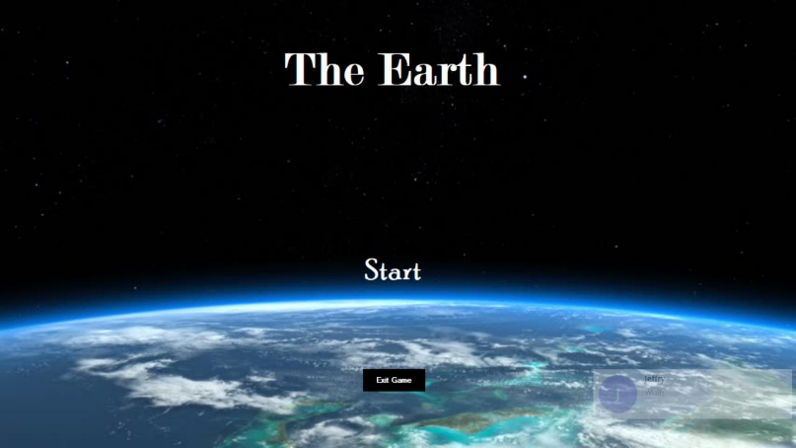 Tampilan *start panel* akan muncul ketika aplikasi mulai digunakan. Berikut ini tampilan *start panel* seperti pada Gambar 1.

**Gambar 1.** Tampilan *Start Panel*

**2. Tampilan Difficulty Panel**

*Difficulty panel*  merupakan tampilan kedua aplikasi setelah *start panel*, pada panel ini terdapat tiga tingkat kesulitan masing-masing. Tampilannya seperti pada gambar 2.

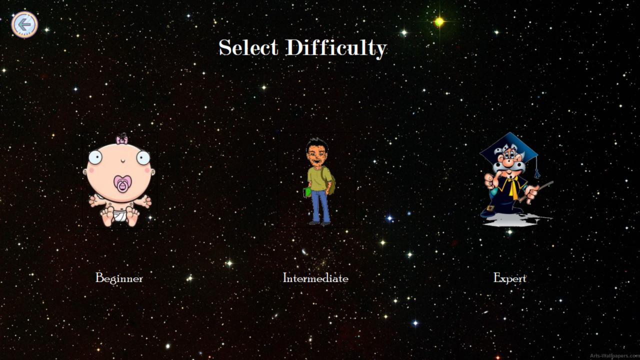

**Gambar 2.** Tampilan *Difficulty Panel*

**3. Tampilan Question Panel**

*Question Panel* merupakan tampilan soal dalam aplikasi. Berikut tampilannya pada gambar 3.

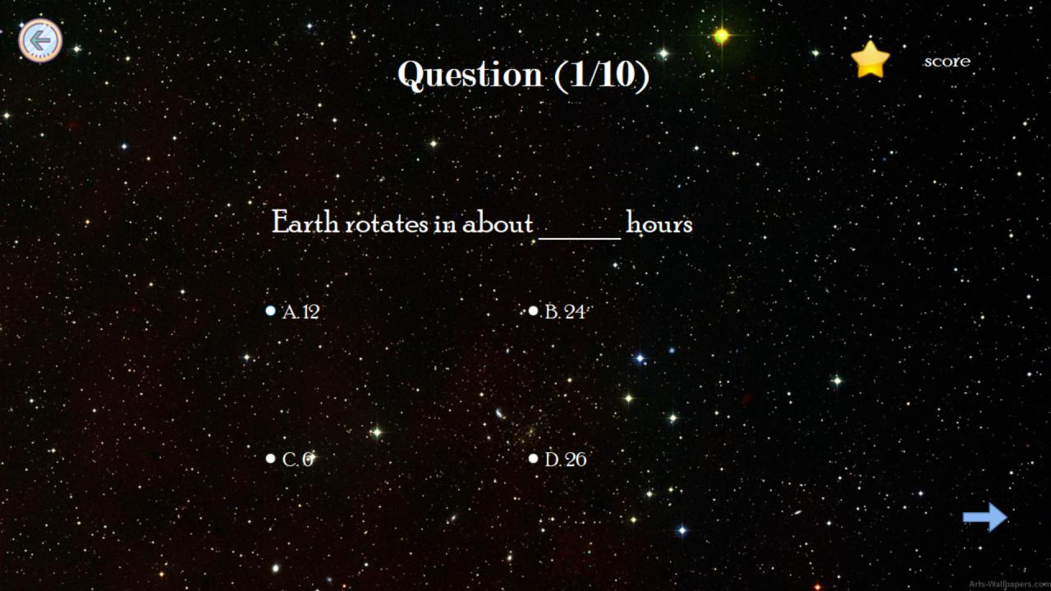

**Gambar 3.** Tampilan *Question Panel*

**4. Tampilan FunFact**

*FunFact* merupakan fakta yang bagus dan akan muncul *random* pada saat setelah menjawab soal seperti pada gambar 4.

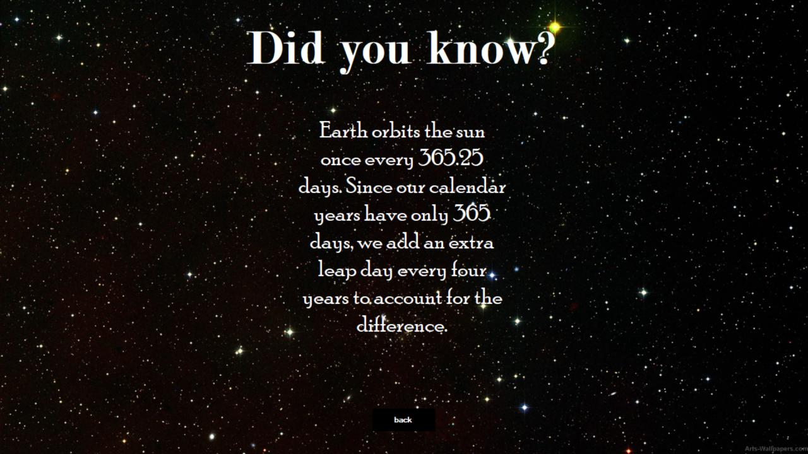

**Gambar 4.** Tampilan *FunFact*

**5. Tampilan Check Answer**

*Check answer* merupakan tampilan yang mengecek apakah jawaban benar (seperti pada gambar 5a) atau salah (seperti pada gambar 5b).

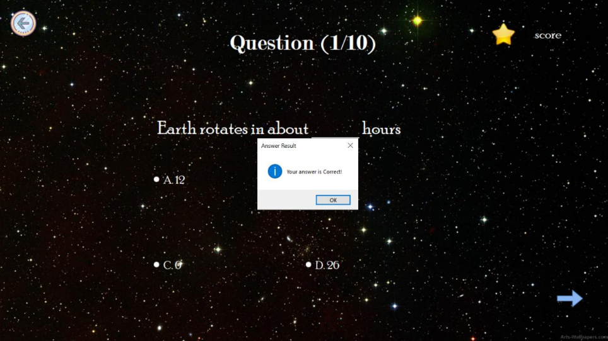

**Gambar 5a.** Tampilan jawaban benar

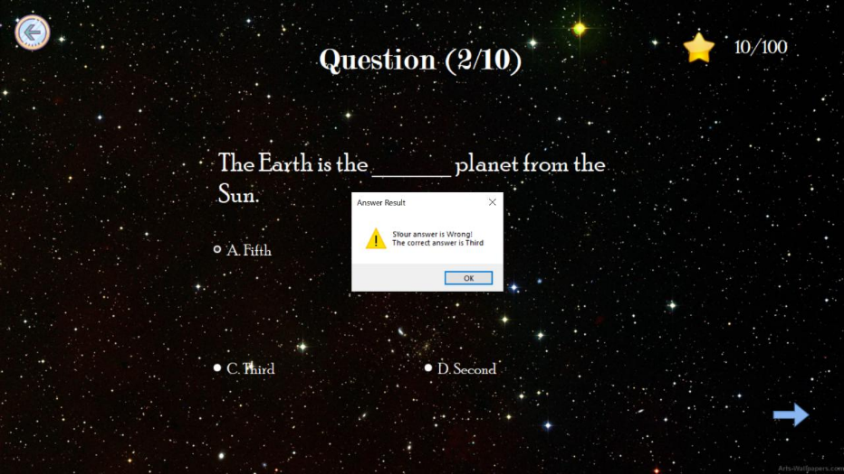

**Gambar 5b.** Tampilan jawaban salah

**6. Tampilan Chapter Complete**

*Chapter complete* merupakan tampilan yang mengindikasikan bahwa permainan telah selesai seperti pada gambar 6.

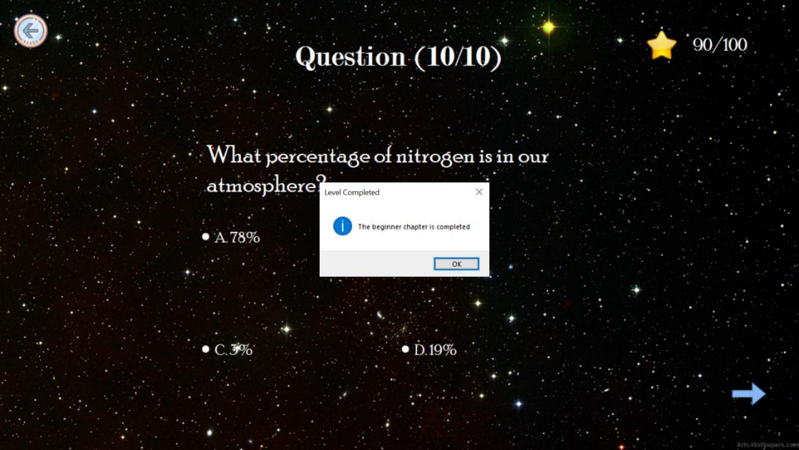

**Gambar 6.** Tampilan *Chapter Complete*

**4.2. PEMBAHASAN**

**4.2.1 Cara Pakai**

1. Install terlebih dahulu Visual Studio 2019 lalu jalankan aplikasi.

2. Tekan *text* *Start*.

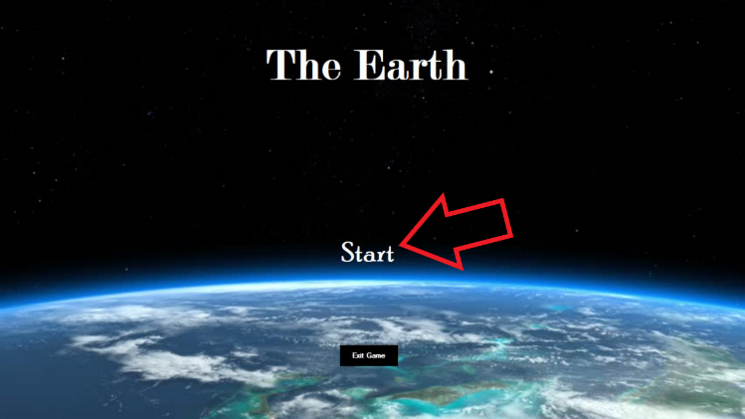

3. Pilih tingkat kesulitan.

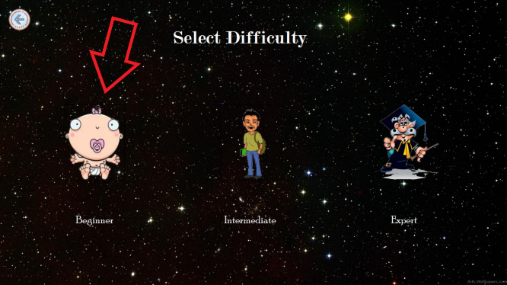

1. Menjawab soal dengan benar.

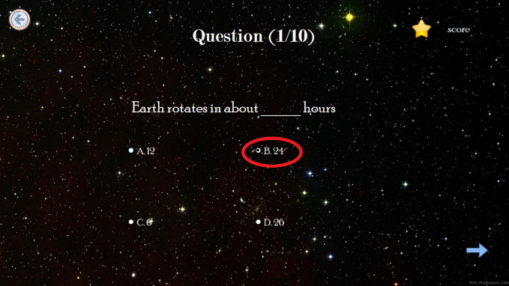

1. Anda dapat melihat skor akhir anda setelah menyelesaikan seluruh soal.

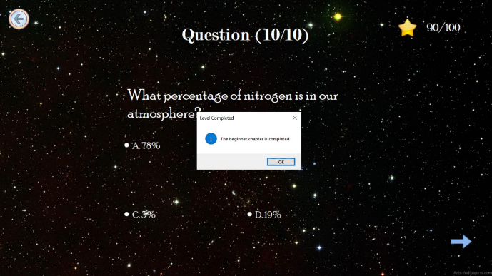

**4.2.2 Instalasi**

1. Download Visual Studio 2019 pada link berikut ini <https://visualstudio.microsoft.com/downloads/>

2. Download Community.

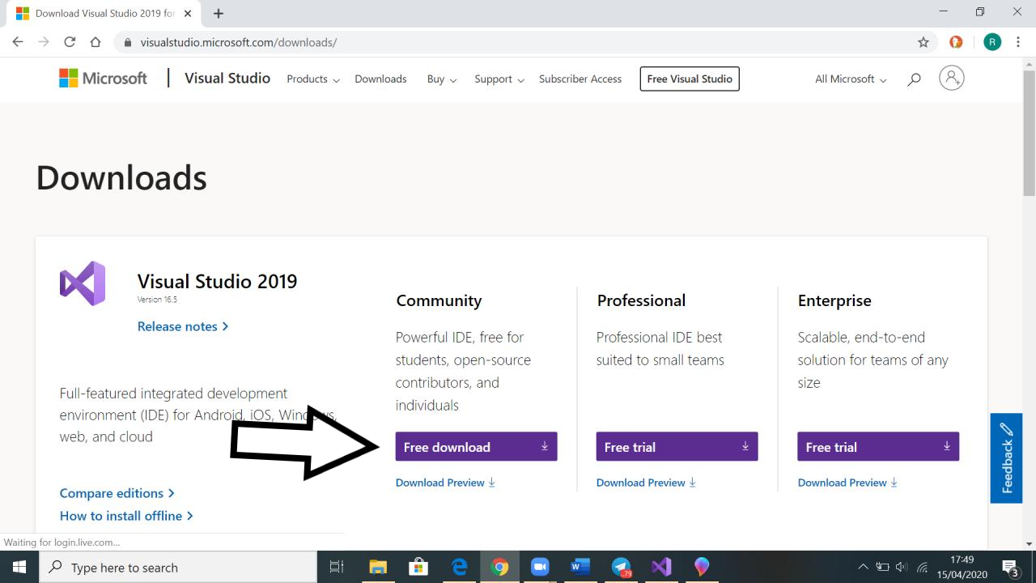

1. Open project pada Visual Studio 2019.

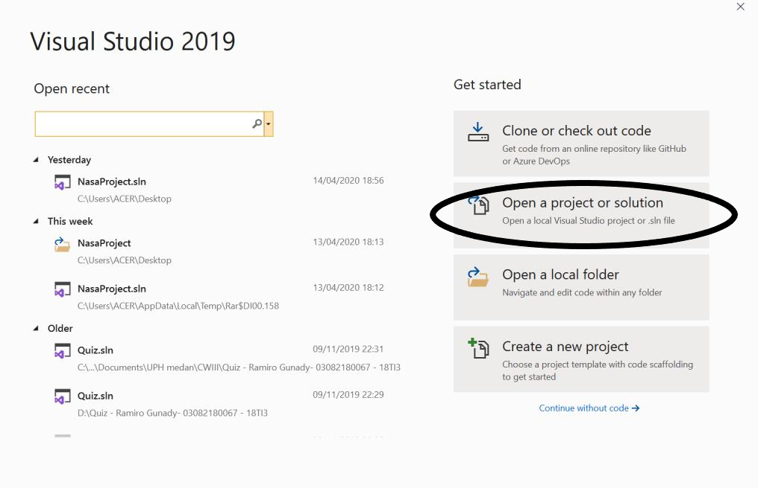

1. Pilih project lalu open.

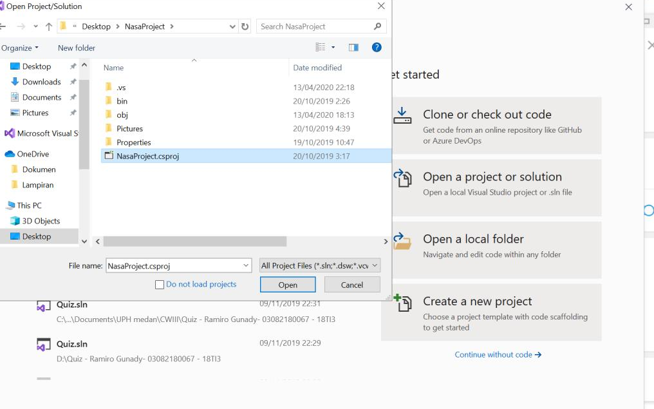

1. Run NasaProject.csproj.

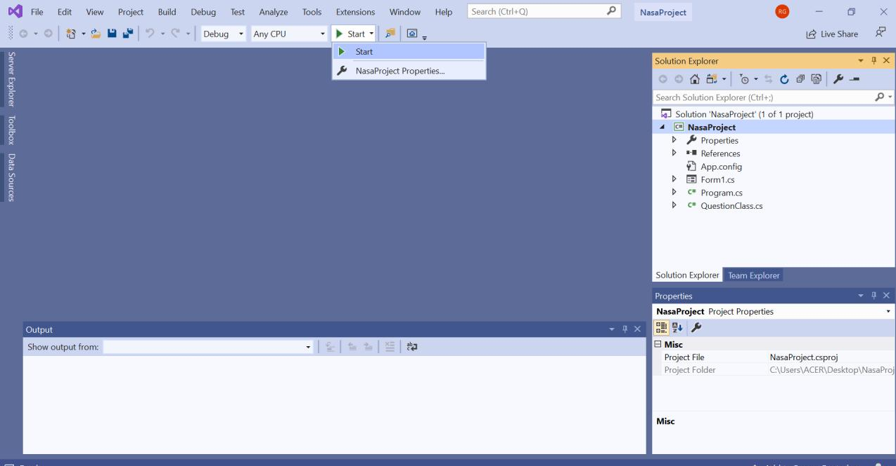

1. 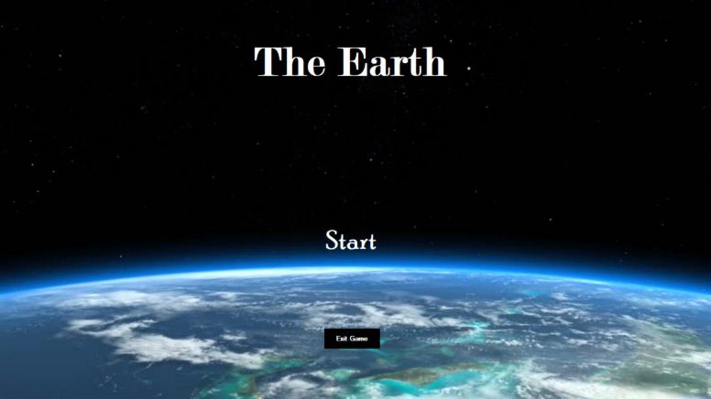Selamat bermain !

**4.2.3 Keunggulan**

Keunggulan dari software ini adalah tampilan yang memiliki icon dan gambar yang menarik serta terdapat funfact informasi tambahan yang dapat diperoleh user serta background yang bertema tata surya.

**4.2.4 Kelemahan**

Kelemahan dari software ini adalah user tidak dapat menyimpan soal yang telah dijawab dan skor ketika keluar dari game.

**BAB V**

**KESIMPULAN & SARAN**

* 1. **Kesimpulan**

Berdasarkan penjelasan dari bab-bab sebelumnya hingga akhir aplikasi Perancangan Game The Earth Berbasis desktop maka dapat di simpulkan sebagai berikut :

Dengan adanya aplikasi Perancangan Game The Earth Berbasis desktop, Pengguna smartphone berbasis pc terutama bagi anak atau untuk kalangan umum dapat menjadikan aplikasi ini sebagai media hiburan dan pengetahuan.

* 1. **Saran**

Disarankan wifi atau internet stabil dan cukup saat melakukan download Visual Studio 2019. Pilih community dikarenkan downloadnya gratis dan sudah cukup dipakai.

**LAMPIRAN**

**Listing Program**

|  |  |
| --- | --- |
| properti | function |
| bacground image | menampilkan background |
| beginner button | membuat gambar pada background |
| beginner check answer | pengecekan level mudah |
| difficulty panel | menampilkan level |
| exitbutton | keluar dari tampilan game |
| expert button | memulai level susah |
| expert check answer | pengecekan level susah |
| fact panel | menampilkan fakta menarik |
| intermediate button | memulai level sedang |
| intermediate check answer | pengecekan level sedang |
| mcqa | radio button a |
| mcqb | radio button b |
| mcqc | radio button c |
| mcqd | radio button d |
| q number | menampilkan no soal |
| question panel | menampilakn pertanyaan |
| select difficulty tabel | memilih level yang akan dimainkan |
| startbutton | memuai permainan |
| startpanel | memuat tampilan awal |